Gesture Controlled Drone

Daniel McGrath
University of Pittsburgh
Department of Electrical and Computer Engineering
djm158@pitt.edu
Dannah Gersh
University of Pittsburgh
Department of Electrical and Computer Engineering
drg42@pitt.edu

Abstract – This project will be concerned with the design and implementation of a gesture controlled unmanned aerial vehicle. The control system will operate via a wearable on the user’s arm. The device will use gyroscope data to determine gestures performed by the operator that translate to drone movements.

Introduction
Piloting an unmanned aerial vehicle (UAV), more commonly known as a drone, is inherently difficult. The controls are often unintuitive and take time and skill to master. This results in a steep learning curve that prevents would-be hobbyists from becoming proper drone pilots. We are proposing a new control system that is far more intuitive than conventional methods.
The conventional method for piloting drones typically consists of two joy sticks, with each direction of the joy stick indicating either roll, pitch, yaw, or throttle. Roll is the motion of rocking from side to side, this results in a motion comparable to a ground vehicle strafing side to side for a quadcopter, and turning in an airplane style vehicle. Pitch is a forward or backward tilt that describes the angle of flight along an axis. The pitch causes forward or backward motion on a quadcopter or ascent or decent in an RC plane. Yaw describes the rotation of a drone about the center axis, which controls the direction it is facing. Throttle controls lift and decent in a quadcopter as well as speed in all UAVs [1]. See Figures 1 and 2 for visual representation.
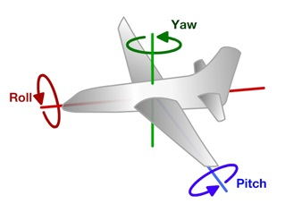
Figure 1
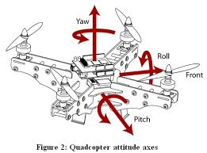
Figure 2

There are typically two modes for drone controllers. In mode 1, the left stick controls pitch and yaw and the right stick controls throttle and roll. Alternatively, for mode 2, the left stick controls throttle and yaw and the right stick controls pitch and roll. Mode 2 is the more popular setting for quadcopter control, as it replicates real world helicopter or quadcopter control systems [2]. Learning either of these systems for flying a drone requires significant time and effort and many crash landings - it is not intuitive for a beginner. An example of a standard drone controller can be seen below in Figure 3.
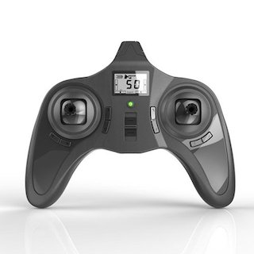
Figure 3
When attempting to imitate or explain the motion of flying vehicles, people typically have several automatic hand gestures that they fall back on to allow their audience to understand the explanation. These gestures are so natural that they are the same ones you could see children use when they so excitedly talk about a toy plane or RC helicopter they received for Christmas. For example, roll is often expressed by tilting the hand to one side or the other, yaw is typically expressed by holding the hand flat at turn it to one side or the other. In addition, Pitch is often visualized as tilting the hand down or up to show that the front of the UAV is tilting in the specified direction and quadcopter throttle causes accent or decent, which can be illustrated by holding the hand flat and making a downward pushing motion, or upward lifting motion respectively.
These hand motions are extremely intuitive and, thus, easy to learn. This leads to the conclusion that it makes sense for flying vehicles to be controlled by these movements as well. Utilizing gesture control for aerial vehicles would make for a far simpler learning processes to become proficient at flying them. There would then be no need to have the skill of a licensed pilot to fly a drone.

Related work

There are a variety of gesture control products available in the market today. Two popular motion control solutions are the Leap motion controller and the Myo Armband. These two products differ in both their intended use case and implementation but are both related to this project’s goal.

The Myo armband is a wearable gesture-based controller that uses EMG muscle sensors as well as a sensitive inertial motion control unit to detect a variety of hand gestures. The device responds to movement of the arm in the Cartesian plane, as well as various hand gestures including pinching fingers together or making a fist [3]. Our project will not take advantage of the EMG muscle sensor feedback as in the Myo armband, but will use inertial motion control to pilot our drone. An example of the Myo armband can be seen below in Figure 3.

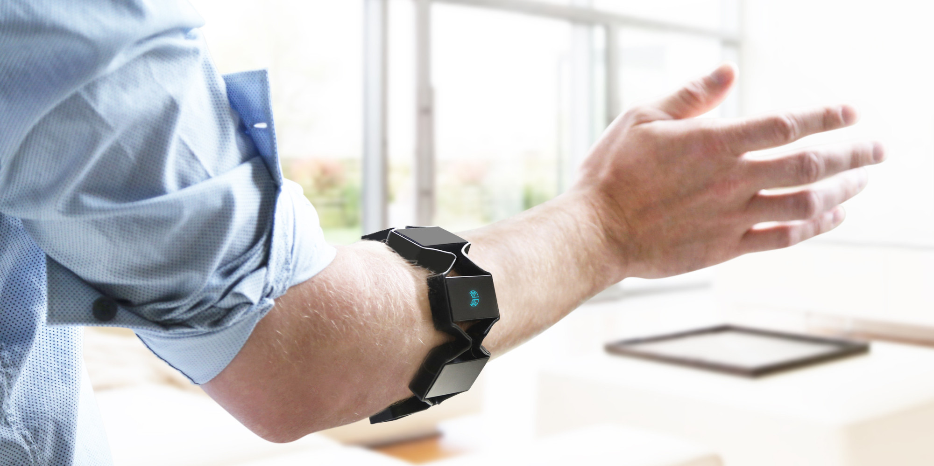
Figure 4: Myo Armband

The Leap Motion Controller is an alternative gesture controller that uses cameras and infrared (IR) sensing to detect hand gestures. Leap is a popular controller in virtual reality (VR) applications, but can also be used in many different real world technologies. The device sits in front of your computer screen and acquires video and IR data to be used to control characters and objects on screen. Leap allows the user a similar set of gestures as the Myo armband, but possibly with more fine grained control and sensitivity to improve the VR experience [4]. This technology could achieve the required gesture control capabilities for our project, but lacks the wearable capabilities exhibited in the Myo. An example of the Leap Motion controller can be seen below in Figure 4.

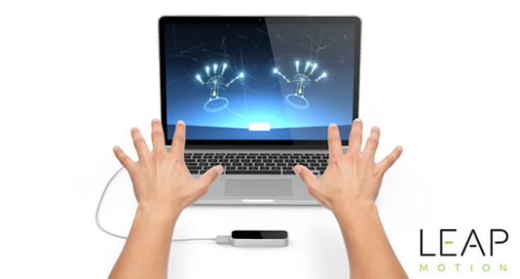
Figure 5: Leap Motion Controller

Technical Background
Our control system relies on the ability to detect the position and motion of both the user’s arm and hand. To do this, we will attach two inertial measurement units (IMU) to the user’s arm and forearm. These will provide us sufficient data to determine the direction the user is tilting their hand and if they are moving it up and down or side to side.
The IMUs will communicate to an embedded microcontroller over I²C protocol. Once the microcontroller receives the position data, software will process and filter the data to send movement signals to a device. The IMUs we used to implement our controller were the Adafruit’s 9 Degrees of Freedom breakout board. This IMU contained an accelerometer, gyroscope, and compass that allows you to capture nine distinct types of motion or orientation related data: 3 degrees each of acceleration, magnetic orientation, and angular velocity. The acceleration data is captured using an accelerometer, the magnetic orientation via a compass, and the angular velocity from a gyroscope [5].
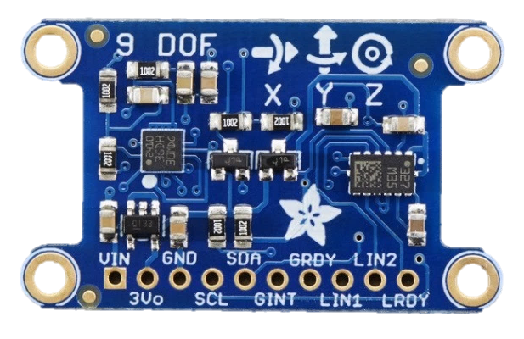
Figure 6: 9 DOF IMU
In our case, we needed to use two IMUs, which have nonprogrammable I²C addresses that are the same for both units. To resolve this problem, we also incorporated a I²C multiplexor. This multiplexer acts as a gatekeeper, shuttling the commands to the correct set of I2C pins after the user selects the device [6].
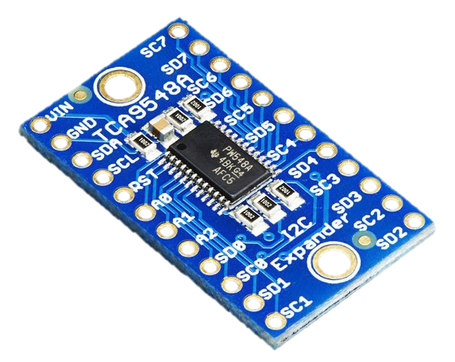
Figure 8: I²C Multiplexor
To communicate with the drone, we also incorporated an nRF24L01+ 2.4GHz wireless transceiver. This module is Arduino compatible and there are several tutorials available online for how to use it. This device makes wireless communication easy, with auto-acknowledge and auto-retransmit capabilities. It also includes an on-board antenna and a communication range of up to 262 feet in ideal conditions. This board interfaced with the Arduino Uno through an nRF24L01+ breakout adapter with a voltage regulator [7].
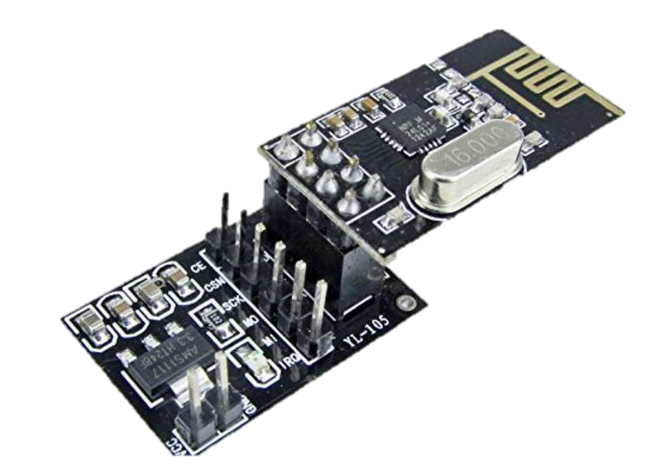
Figure 9: nRF24L01+ 2.4GHz Transceiver and Adapter
The final hardware component we used was an Arduino Uno microcontroller. It has 14 digital input/output pins, 6 analog inputs, a 16 MHz quartz crystal, a USB connection, a power jack, an ICSP header, and a reset button. This is an easy board to prototype with, because it is cheap and easy to replace and reprogram [8].
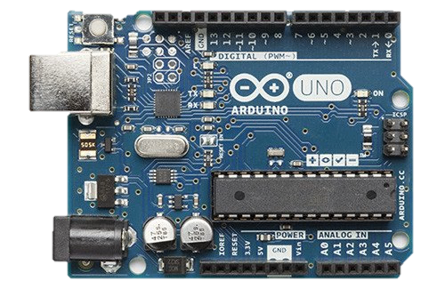
Figure 10: Arduino Uno
To test our design, we had to get a drone to control. We chose to purchase a Cheerson CX-10 Mini-Drone. This drone has a 2.4 GHz, 4 channel wireless control system, which matches the wireless transmitter we chose for our controller. This mini drone was inexpensive and has good reviews for reliability. This made it a good choice for testing our control system, because we could tell if any bugs were related to the controller or due to a problem with the drone [9]. The drone had a battery life of about 5 minutes, which was more than enough time for the testing we needed to do. It also charged very quickly, within approximately two minutes from zero battery power to one hundred percent.
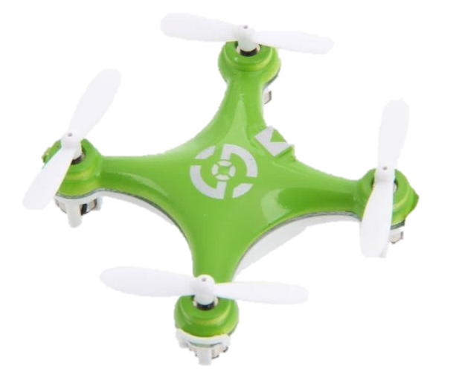
Figure 11: Cheerson CX-10 Mini-Drone

Design Description
The basis of our design is to create a wearable with two gyroscopes, a micro controller, and a Bluetooth chip that can be used to translate gestures to control a quadcopter drone. The wearable will consist of two bands, one around the lower arm, the other on the hand, with one gyroscope connected to the top of the hand and the processor, Bluetooth, and second gyro connected to the arm band. A basic illustration of this concept can be seen in Figure 6 below.
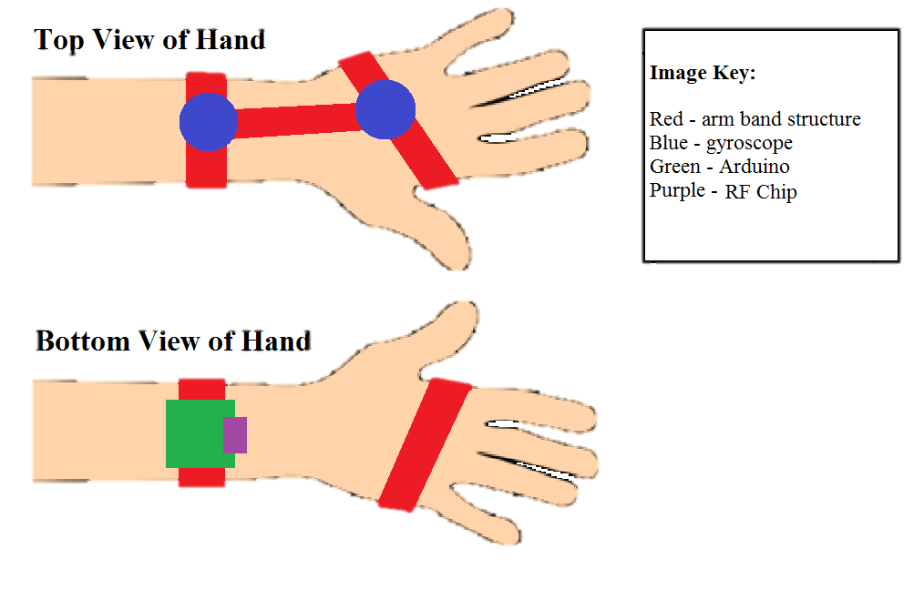
Figure 12: Hardware Layout Concept
The gyroscopes will measure the angles of tilt of the arm and hand both side to side and up and down. The processor will use the measurements to determine the gesture being performed by the user. It will then translate that into the same signal that would be transmitted to a drone by a standard controller. The Bluetooth chip is the final piece that will send that signal to the drone.
The gestures that will be used to replace joystick controls are as follows:
- Roll – side to side tilting of the hand
- Pitch – upward pitch is indicated by tilting the hand upward, fingers toward the sky, while downward pitch is indicated by tilting the hand downward, fingers toward the earth.
- Yaw – angling the whole arm sideway, either left or right depending on the direction of yaw desired. Based on wearing the device on the left hand, to adjust the yaw toward the right, the arm would turn toward the body, to yaw left would turn the arm away from the body.
- Throttle – tilt the entire lower arm up or down. This will cause the quadcopter to ascend or descend.
Different combinations of these gestures will also be available for flexibility of movement. This will allow the drone to not be restricted to one axis of movement at a time and thus could, for example, move upward and forward at the same in a diagonal path rather than having to perform these motions in sequence.
Gyroscope data tends to be noisy, so we will use certain thresholds to restrict the device to initiate movement only when that threshold is crossed to stabilize the data for accurate gesture recognition. This will also avoid erratic and unexpected flight patterns that could result in a potentially dangerous crash. These restrictions will allow for gestures will be clear, well defined, and easy to replicate, leading to choosing the gestures explained previously.

Technology Details and Contributions
A system that meets our requirements should:
- Cause the drone to fly drone upwards or downwards as the hand is raised or lowered vertically, causing the wrist-mounted sensor to reach a specified pitch threshold.
- Cause the drone to strafe left or right (depending on the direction the drone is facing) when the hand is tilted left or right, respectively, causing the hand-mounted sensor to reach specified thresholds for movement depending upon the command.

Hardware
Each of the IMUs we used in our design have the same I2C address, thus they cannot share a single I2C bus [5]. To solve this problem, we multiplexed the I2C pins on the arduino using the Adafruit TCA9548A I2C multiplexer. This allowed us to write software that could switch which sensor we received data from by writing a digital signal to a specific pin [6].
Since the nRF24L01 chip is controlled through the Arduino’s SPI interface, simply connecting the proper SPI pins allows the device to function properly. This device was used for the wireless communication with the selected drone, which is on a simple, unsecured wireless channel. The data packets that the chip sent to the drone were controlled through software libraries provided by the vendor. The wiring for the chip is as follows [7]:

Arduino Uno | nRF24L01+Adapter Board | Wire Color  (See Figure 14)
GND | GND | Orange
5V | VCC | Red
D5 | CE | Yellow
A1 | CSN | Green
D4 | SCK | Blue
D3 | MO (MOSI) | Purple
A0 | MI (MISO) | Gray
Figure 13: nRF24L01 to Arduino Uno Wiring
Finally, once the system is completely wired correctly, it must be mounted as a wearable on a person’s arm. To do this, we used some cloth that covered the user’s hand and wrist, and then used Velcro to attach the components to the cloth to make it adjustable. Both IMUs must have the x-axis of the chip facing forward toward the wearer’s fingers (marked on the chip). The first IMU, that controls roll and pitch, is mounted on the back of the hand, while the second IMU, which controls throttle, and the I²C multiplexer are mounted on to top of the forearm, slightly below the wrist. Finally, the Arduino and the nRF chip are mounted below the forearm, approximately aligned with the multiplexer, although their placement is not critical. The wires between the hand IMU and the multiplexor must be long enough to allow for flexing of the wrist.
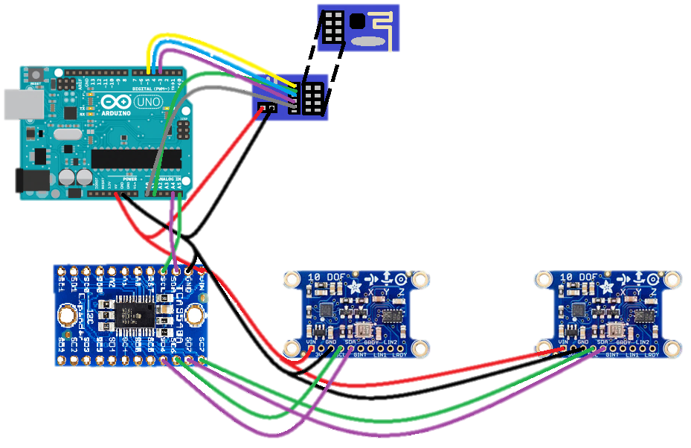
Figure 14: Full Hardware Layout

Software
The software component of the system is primarily organized as a state machine that makes decisions based on real time data acquired from the IMUs. First, we check for accelerometer events on each of the IMUs. If an accelerometer even has occurred, we know that the wearer has made a movement, and the software should check what that movement was and adjust the drone signals accordingly. We then use these events to read orientation data from the devices. Finally, we use the orientation to determine the control data fields of the packets sent to the drone.
Adafruit provides several libraries and drivers containing helper functions that allow us to interface with the IMUs and their sensors. The first of these interfaces is the Adafruit_LSM303_Accel_Unified library, used as an interface with the on-chip accelerometer. This interface provides the function getEvent(), which takes a sensors_event_t struct as an argument and populates it with data from the accelerometer. Based on this event data, we use Adafruit’s Adafruit_9DOF interface to process the various orientation fields given by the device. This library provides the function accelGetOrientation, which takes a sensors_event_t struct and a sensors_vec_t struct as arguments, which are used to store the orientation data.
We process the orientation data differently for either IMU, as they each correspond to different changes in motion by the drone. The order is not a crucial element of the system, so we arbitrarily process the sensor mounted on the user’s wrist first, which we use to control the drone’s throttle. To do this, we need to call a tcaselect() function, which takes an integer that selects which port on the I2C multiplexer to read and write data from. Since we wired the throttle control to port 6, we call tcaselect(6). For this sensor, we use the IMUs pitch to determine whether we should increase or decrease the throttle or simply maintain. If the pitch rises above or falls below a specific threshold, we adjust the throttle (which is a packet sent to the drone) accordingly based on experimentally determined values.
The logic for processing the data from the hand-mounted sensor is extremely similar to that of the wrist-mounted sensor. We follow the same logic to read accelerometer data and gather orientation information as before. One difference worth noting is that we must call tcaselect(7), since this IMU is wired to port 7 on the I2C multiplexer. In addition to recording data for the sensor’s pitch, we also record the roll. These fields allow us to determine the aileron (the packet that controls left and right strafing) and elevator (the packet that controls forward and backward strafing), respectively. If roll is below a predetermined threshold, the drone will strafe left, and if it is above predetermined threshold, it will strafe right. The same is true for pitch, except that when it is below our threshold the drone moves forward and when it is above the threshold it moves backwards. The state machine can be seen below represented by a control flow diagram:
Figure 15: Control Flow Diagram for Gyroscope Data to Drone Control Signals
We used an open source implementation of the quadcopter’s RF protocol to communicate control data. This library contained a WritePacket() function which communicated the control data we stored in an array to the drone. We simply had to place variables for throttle, aileron, elevator, and rudder (which was not used) into the first four indices of an array and call WritePacket() to communicate the payload to the quadcopter. Each data field in the array is sent through a different RF channel. Although the drone can use up to 12 channels for various calibration settings, we used only the first four to simplify our controls. The general control diagram for the software system can be found in entry A of the Appendix, and the full code can be seen in entry B of the Appendix.

System Testing and Results
We tested the system in a bottom up fashion. First, we connected one of the IMUs to the Arduino and wrote a simple test script to detect accelerometer and orientation data. We simply printed the data fields for pitch, roll, and yaw out to the serial monitor and moved the sensor in various directions, looking for appropriate changes in the data fields printed to the monitor.
Next, we tested the nRF24L01 chip to determine if we could control the drone with the Arduino. To do this, we wrote a python script that read in keyboard values that adjusted the throttle, aileron, elevator, and rudder values per the length of time the user pressed a specific key. This required writing data packets to the COM port connecting the CPU and the Arduino, as well as adding Arduino code to parse the text data sent to it via the USB connection. This allowed us to get an idea of the sensitivity of the drone to different throttle, pitch, and roll values and adjust them accordingly. This python script can be found in entry C of the Appendix.
The final phase of system testing required hooking up the Adafruit sensor libraries with the open source nRF24L01 code. Although we expected this to be difficult, we found that modules we used worked seamlessly with one another. We were able to collect all the necessary data to send to the quadcopter in an array, and then write the array as the payload to the drone. We needed to adjust the levels for throttle, aileron, and elevator to allow the user to fly the drone without drastic increases in throttle or strafing wildly. These values were determined experimentally, through a lot of trial and error testing, but once the proper adjustments were made the system functioned as expected.

Conclusion and Future Work
This paper presented a design for a gesture control system for drone flight. Two IMUs, a wireless chip, and an Arduino Uno were used to record, process and send data from the wearer to the drone. The IMUs recorded motion and orientation data, which was processed based on control software on the Arduino, which then formatted nRF packets to send to the drone via the nRF24L01 wireless chip. This configuration allowed us to successful implement a self-contained, wearable, embedded system that allows a user to control a drone using gestures.
Future work on this project could be extensive. We have not implemented rotation (yaw) of the vehicle, which could become useful when trying to use this system to control a drone that has a camera, to allow the user to turn the drone and see more of its surroundings. There are also many finer controls that we did not implement, such as drone gyroscope calibration as well as network security. Ideally this could be a government contracted project, in which case establishing a secure connection between the controller and the drone would be essential.

References
- S. French, "Everything you need to know about your drone’s remote control," in The Drone Girl, The Drone Girl, 2016. [Online]. Available: https://thedronegirl.com/2016/01/21/everything-you-need-to-know-about-your-drones-remote-control/. Accessed: Sep. 29, 2016.
- "How to use a drone controller," in Drone Buff, Drone Buff, 2014. [Online]. Available: http://dronebuff.com/drone-controller/. Accessed: Sep. 29, 2016.
- "Myo gesture control Armband," 2013. [Online]. Available: https://www.myo.com/techspecs. Accessed: Sep. 29, 2016.
- "Leap Motion," 2016. [Online]. Available: https://www.leapmotion.com/product/desktop. Accessed: Sep. 29, 2016.
- K. Townsend, "Introduction," in Adafruit. [Online]. Available: https://learn.adafruit.com/adafruit-9-dof-imu-breakout/introduction. Accessed: Dec. 16, 2016.
- E. Tufte, "Overview,". [Online]. Available: https://learn.adafruit.com/adafruit-tca9548a-1-to-8-i2c-multiplexer-breakout/overview. Accessed: Dec. 16, 2016.
- "Addicore nRF24L01+ wireless AddiKit with socket adapter boards and jumper wires," in Addicore, Addicore, 2014. [Online]. Available: http://www.addicore.com/nRF24L01-Wireless-AddiKit-p/129.htm. Accessed: Dec. 16, 2016.
- "ArduinoBoardUno," in Aduino, 2016. [Online]. Available: https://www.arduino.cc/en/Main/ArduinoBoardUno. Accessed: Dec. 16, 2016.
- Amazon, "Cheerson CX-10 Mini 2.4G 4CH 6 axis LED RC Quadcopter toy drone," in Amazon.com: Toys & Games, Amazon. [Online]. Available: https://www.amazon.com/Cheerson-CX-10-Mini-Quadcopter-Drone/dp/B00KXZC762. Accessed: Dec. 16, 2016.

Appendix

Software Flow Control Diagram
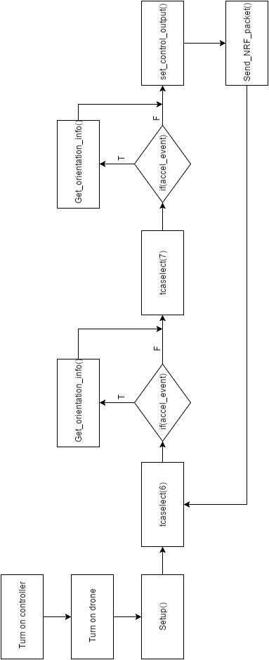

Main Program Code
#include <util/atomic.h>
#include <EEPROM.h>
#include "iface_nrf24l01.h"
#include <string.h>

#include <Wire.h>
#include <Adafruit_Sensor.h>
#include <Adafruit_LSM303_U.h>
#include <Adafruit_L3GD20_U.h>
#include <Adafruit_9DOF.h>

extern "C" {
#include "utility/twi.h"
}

/* Assign a unique ID to the sensors */
Adafruit_9DOF dof = Adafruit_9DOF();
Adafruit_LSM303_Accel_Unified accel1 = Adafruit_LSM303_Accel_Unified(30301);
Adafruit_LSM303_Mag_Unified mag1 = Adafruit_LSM303_Mag_Unified(30302);

/* Assign a unique ID to the sensors */
Adafruit_LSM303_Accel_Unified accel2 = Adafruit_LSM303_Accel_Unified(30303);
Adafruit_LSM303_Mag_Unified mag2 = Adafruit_LSM303_Mag_Unified(30304);

// ############ Wiring ################
#define PPM_pin 2 // PPM in
//SPI Comm.pins with nRF24L01
#define MOSI_pin 3 // MOSI - D3
#define SCK_pin 4 // SCK - D4
#define CE_pin 5 // CE - D5
#define MISO_pin A0 // MISO - A0
#define CS_pin A1 // CS - A1
#define TCAADDR 0x70

#define ledPin 13 // LED - D13

// SPI outputs
#define MOSI_on PORTD |= _BV(3) // PD3
#define MOSI_off PORTD &= ~_BV(3)// PD3
#define SCK_on PORTD |= _BV(4) // PD4
#define SCK_off PORTD &= ~_BV(4) // PD4
#define CE_on PORTD |= _BV(5) // PD5
#define CE_off PORTD &= ~_BV(5) // PD5
#define CS_on PORTC |= _BV(1) // PC1
#define CS_off PORTC &= ~_BV(1) // PC1
// SPI input
#define MISO_on (PINC & _BV(0)) // PC0

#define RF_POWER TX_POWER_80mW

// PPM stream settings
#define CHANNELS 12 // number of channels in ppm stream, 12 ideally
enum chan_order{
THROTTLE,
AILERON,
ELEVATOR,
RUDDER,
AUX1, // (CH5) led light, or 3 pos. rate on CX-10, H7, or inverted flight on H101
AUX2, // (CH6) flip control
AUX3, // (CH7) still camera (snapshot)
AUX4, // (CH8) video camera
AUX5, // (CH9) headless
AUX6, // (CH10) calibrate Y (V2x2), pitch trim (H7), RTH (Bayang, H20), 360deg flip mode (H8-3D, H22)
AUX7, // (CH11) calibrate X (V2x2), roll trim (H7)
AUX8, // (CH12) Reset / Rebind
};

#define PPM_MIN 1000
#define PPM_SAFE_THROTTLE 1050
#define PPM_MID 1500
#define PPM_MAX 2000
#define PPM_MIN_COMMAND 1300
#define PPM_MAX_COMMAND 1700
#define GET_FLAG(ch, mask) (ppm[ch] > PPM_MAX_COMMAND ? mask : 0)

// supported protocols
enum {
PROTO_V2X2 = 0, // WLToys V2x2, JXD JD38x, JD39x, JJRC H6C, Yizhan Tarantula X6 ...
PROTO_CG023, // EAchine CG023, CG032, 3D X4
PROTO_CX10_BLUE, // Cheerson CX-10 blue board, newer red board, CX-10A, CX-10C, Floureon FX-10, CX-Stars (todo: add DM007 variant)
PROTO_CX10_GREEN, // Cheerson CX-10 green board
PROTO_H7, // EAchine H7, MoonTop M99xx
PROTO_BAYANG, // EAchine H8(C) mini, H10, BayangToys X6, X7, X9, JJRC JJ850, Floureon H101
PROTO_SYMAX5C1, // Syma X5C-1 (not older X5C), X11, X11C, X12
PROTO_YD829, // YD-829, YD-829C, YD-822 ...
PROTO_H8_3D, // EAchine H8 mini 3D, JJRC H20, H22
PROTO_END
};

// EEPROM locations
enum{
ee_PROTOCOL_ID = 0,
ee_TXID0,
ee_TXID1,
ee_TXID2,
ee_TXID3
};

uint16_t overrun_cnt=0;
uint8_t transmitterID[4];
uint8_t current_protocol;
static volatile bool ppm_ok = false;
uint8_t packet[32];
static bool reset=true;
volatile uint16_t Servo_data[12];
static uint16_t ppm[12] = {PPM_MIN,PPM_MID,PPM_MID,PPM_MID,PPM_MID,PPM_MID,
PPM_MID,PPM_MID,PPM_MID,PPM_MID,PPM_MID,PPM_MID,};

String inputString = ""; // a string to hold incoming data
boolean stringComplete = false; // whether the string is complete
char *p, *i;
char* c = new char[200 + 1]; // match 200 characters reserved for inputString later
char* errpt;
uint8_t ppm_cnt;

// vars to send to drone
int throttle, aileron, elevator, rudder;

// IMU data
float roll, throttle_pitch, elevator_pitch, yaw;

void tcaselect(uint8_t i)
{
if(i > 7) return;
Wire.beginTransmission(TCAADDR);
Wire.write(1 << i);
Wire.endTransmission();

}

void setup()
{

randomSeed((analogRead(A4) & 0x1F) | (analogRead(A5) << 5));
pinMode(PPM_pin, INPUT);
pinMode(MOSI_pin, OUTPUT);
pinMode(SCK_pin, OUTPUT);
pinMode(CS_pin, OUTPUT);
pinMode(CE_pin, OUTPUT);
pinMode(MISO_pin, INPUT);

// PPM ISR setup
//attachInterrupt(PPM_pin - 2, ISR_ppm, CHANGE);
TCCR1A = 0; //reset timer1
TCCR1B = 0;
TCCR1B |= (1 << CS11); //set timer1 to increment every 1 us @ 8MHz, 0.5 us @16MHz

set_txid(false);

// Serial port input/output setup
Serial.begin(115200);
// reserve 200 bytes for the inputString:
//inputString.reserve(200);
Wire.begin();
for(uint8_t t =0; t<8; t++)
{
tcaselect(t);
Serial.print("TCA Port #"); Serial.println(t);

for(uint8_t addr = 0; addr <=127; addr++)
{
//Serial.print("addr: "); Serial.println(addr);
if(addr == TCAADDR) continue;

uint8_t data;
if(!twi_writeTo(addr, &data, 0, 1, 1))
{
Serial.print("Found I2C 0x"); Serial.println(addr, HEX);
}
}
}
/* Initialise the sensors */
tcaselect(6);
if(!accel1.begin())
{
/* There was a problem detecting the LSM303 ... check your connections */
Serial.println(F("Ooops, no LSM303 detected ... Check your wiring!"));
while(1);
}
if(!mag1.begin())
{
/* There was a problem detecting the LSM303 ... check your connections */
Serial.println("Ooops, no LSM303 detected ... Check your wiring!");
while(1);
}

tcaselect(7);
if(!accel2.begin())
{
Serial.println(F("accel 2 not detected"));
while(1);
}

if(!mag2.begin())
{
Serial.println(F("mag2 not detected"));
}
throttle = 1000;
aileron = elevator = rudder = 1500;
roll = throttle_pitch = yaw = elevator_pitch = 0.0;

/* Display some basic information on this sensor */
}

void loop()
{
uint32_t timeout;
sensors_event_t event;

// reset / rebind
//Serial.println("begin loop");
if(reset || ppm[AUX8] > PPM_MAX_COMMAND) {
reset = false;
Serial.println("selecting protocol");
selectProtocol();
Serial.println("selected protocol.");
NRF24L01_Reset();
Serial.println("nrf24l01 reset.");
NRF24L01_Initialize();
Serial.println("nrf24l01 init.");
init_protocol();
Serial.println("init protocol complete.");
}
// process protocol
//Serial.println("processing protocol.");
switch(current_protocol) {
case PROTO_CG023:
case PROTO_YD829:
timeout = process_CG023();
break;
case PROTO_V2X2:
timeout = process_V2x2();
break;
case PROTO_CX10_GREEN:
case PROTO_CX10_BLUE:
timeout = process_CX10(); // returns micros()+6000 for time to next packet.
break;
case PROTO_H7:
timeout = process_H7();
break;
case PROTO_BAYANG:
timeout = process_Bayang();
break;
case PROTO_SYMAX5C1:
timeout = process_SymaX();
break;
case PROTO_H8_3D:
timeout = process_H8_3D();
break;
}
// updates ppm values out of ISR
//update_ppm();
overrun_cnt=0;

sensors_event_t accel_event1;
sensors_event_t mag_event1;
sensors_vec_t orientation1;

sensors_event_t accel_event2;
sensors_event_t mag_event2;
sensors_vec_t orientation2;

tcaselect(6);
/* Calculate pitch and roll from the raw accelerometer data */
accel1.getEvent(&accel_event1);
if (dof.accelGetOrientation(&accel_event1, &orientation1))
{

throttle_pitch = orientation1.pitch;
Serial.print(F("Sensor 1: Pitch: "));
Serial.print(orientation1.pitch);
Serial.print(F("; "));
}

// throttle control
if(throttle_pitch > 35.0)
{
throttle = 1410;
}
else if(throttle_pitch < -35)
{
if(throttle <= 1000){
throttle = 1000;
}
else{
throttle -= 2;
}
}
else{
if(throttle > 1430)
{
throttle = 1400;
}
else if(throttle < 1000){
throttle = 1000;
}
}
Serial.println("");
Serial.print(F("Throttle: "));
Serial.print(throttle);

// end throttle control

tcaselect(7);
accel2.getEvent(&accel_event2);
if (dof.accelGetOrientation(&accel_event2, &orientation2))
{
Serial.println();
elevator_pitch = orientation2.pitch;
Serial.print(F("Sensor 2: Pitch: "));
Serial.print(orientation2.pitch);
Serial.print(F("; "));

roll = orientation2.roll;
Serial.print(F("Sensor 2 Roll: "));
Serial.print(orientation2.roll);
Serial.print(F("; "));
}

if(roll < -25.0)
{
aileron = 1370;
}
else if(roll > 25)
{
aileron = 1630;
}
else{
aileron = 1500;
}
Serial.println("");
Serial.print(F("Aileron: "));
Serial.print(aileron);

// Elevator control
if(elevator_pitch < -25.0)
{
// create a ceiling so that the value for throttle doesn't increase infinitely
elevator = 1630;

}
else if(elevator_pitch > 25)
{
elevator = 1350;

}
else{
elevator = 1500;
}
Serial.println("");
Serial.print(F("Elevator: "));
Serial.print(elevator);

//delay(1000);
ppm[0] = throttle;
ppm[1] = aileron;
ppm[2] = elevator;
ppm[3] = rudder;

Serial.println(F(""));

// wait before sending next packet
while(micros() < timeout) // timeout for CX-10 blue = 6000microseconds.
{
//overrun_cnt+=1;
};
}

void set_txid(bool renew)
{
uint8_t i;
for(i=0; i<4; i++)
transmitterID[i] = EEPROM.read(ee_TXID0+i);
if(renew || (transmitterID[0]==0xFF && transmitterID[1]==0x0FF)) {
for(i=0; i<4; i++) {
transmitterID[i] = random() & 0xFF;
EEPROM.update(ee_TXID0+i, transmitterID[i]);
}
}
}

void selectProtocol()
{
// Modified and commented out lines so that Cheerson CX-10 Blue is always selected

// wait for multiple complete ppm frames
ppm_ok = false;

//if(ppm[RUDDER] < PPM_MIN_COMMAND) // Rudder left
set_txid(true); // Renew Transmitter ID

current_protocol = PROTO_CX10_BLUE; // Cheerson CX10(blue pcb, newer red pcb)/CX10-A/CX11/CX12 ...

// update eeprom
EEPROM.update(ee_PROTOCOL_ID, current_protocol);
}

void init_protocol()
{
switch(current_protocol) {
case PROTO_CG023:
case PROTO_YD829:
CG023_init();
CG023_bind();
break;
case PROTO_V2X2:
V2x2_init();
V2x2_bind();
break;
case PROTO_CX10_GREEN:
case PROTO_CX10_BLUE:
CX10_init();
CX10_bind();
Serial.println("cx10-initialized and bound");
break;
case PROTO_H7:
H7_init();
H7_bind();
break;
case PROTO_BAYANG:
Bayang_init();
Bayang_bind();
break;
case PROTO_SYMAX5C1:
Symax_init();
SymaX_bind();
break;
case PROTO_H8_3D:
H8_3D_init();
H8_3D_bind();
break;
}
}

Python Testing Script

# -*- coding: utf-8 -*-
"""
Sends commands to Arduino Uno via serial port to control a drone
using the nRF24L01 wireless boards.

The arrow keys control elevator and aileron (forward/reverse and left/right)
and the w,s keys control throttle, and the a,d, keys control the rudder (yaw)

This uses the msvcrt library, so it only works under Windows.
"""
import serial, time, msvcrt

throttle=1000
aileron=1500
elevator=1500
rudder=1500 #yaw, rotates the drone

tg=15
ag=15
eg=15
rg=15
try:
arduino=serial.Serial('COM4', 115200, timeout=.01)
time.sleep(1) #give the connection a second to settle
#arduino.write("1500, 1500, 1500, 1500\n")
while True:

data = arduino.readline()
if data:
#String responses from Arduino Uno are prefaced with [AU]
print "[AU]: "+data

if msvcrt.kbhit():
key = ord(msvcrt.getch())
if key == 27: #ESC
print "[PC]: ESC exiting"
break
elif key == 13: #Enter
#select()
print "[PC]: Enter"
elif key == 119: #w
if throttle > 1600:
throttle = 1500
else:
throttle+=tg
elif key == 97: #a
rudder-=rg
elif key == 115: #s
throttle-=tg
elif key == 100: #d
rudder+=rg
elif key == 224: #Special keys (arrows, f keys, ins, del, etc.)
key = ord(msvcrt.getch())
if key == 80: #Down arrow
elevator-=eg
elif key == 72: #Up arrow
elevator+=eg
elif key == 77: #right arroww
aileron+=ag
elif key == 75: #left arrow
aileron-=ag

command="%i,%i,%i,%i"% (throttle, aileron, elevator, rudder)
# string commands to the Arduino are prefaced with [PC]
print "[PC]: "+command
arduino.write(command+"\n")

finally:
# close the connection
arduino.close()
# re-open the serial port which will also reset the Arduino Uno and
# this forces the quadcopter to power off when the radio loses conection.
arduino=serial.Serial('COM4', 115200, timeout=.01)
arduino.close()
# close it again so it can be reopened the next time it is run.

